Vagrant – A tool for working with Virtual Machines.

* A modular framework for working with VMs

It all starts through a Vagrant file, it all starts here.

Two important P words in Vagrant: Provisioners and Providers.

Providers provide virtualization support. They magic VMs into existence.

Two types of Providers: Local and Remote.

Local – VirtualBox, libvirt, VMWare, Docker

Remote – OpenStack, Digital Ocean, AWS

Provisioners provision the VM. They do shared, repeatable configuration. There are also powerful options like Ansible, Puppet, Chef, and Salt.

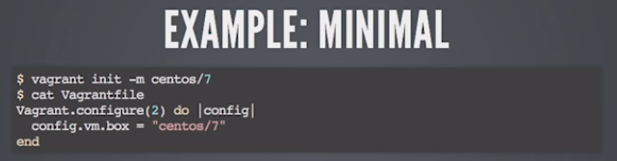

-m and then the name of the box.

Then it’s the file that we are catting out in the second command there. Then start a centos 7 environment with no additional configuration.

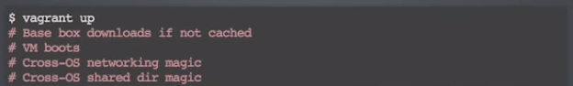

We can then boot that virtual machine with vagrant up. It performs the commented out actions above.



We then connect with SSH and we have a shell in our new machine.

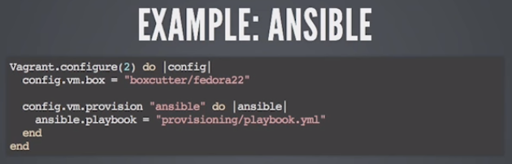

Second chunk is the provision for the ansible handler. We are pointing at a playbook file.

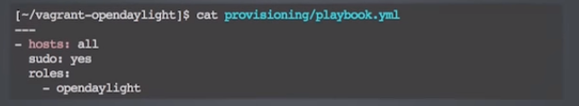

Vagrant up



